http://mandypc:8399/201504layer/
http://mandypc:8099/arcgismanager/main/main.jsf （ arcgismanager / gisserver ）

http://proceedings.esri.com/library/userconf/feduc08/papers/techworkshops/feduc2008_arcgisserver_webadf.pdf

看视频和资料
Gis plugin

C:\Program Files (x86)\ArcGIS\java\tools\eclipse_plugin\arcgis_update_site\engine
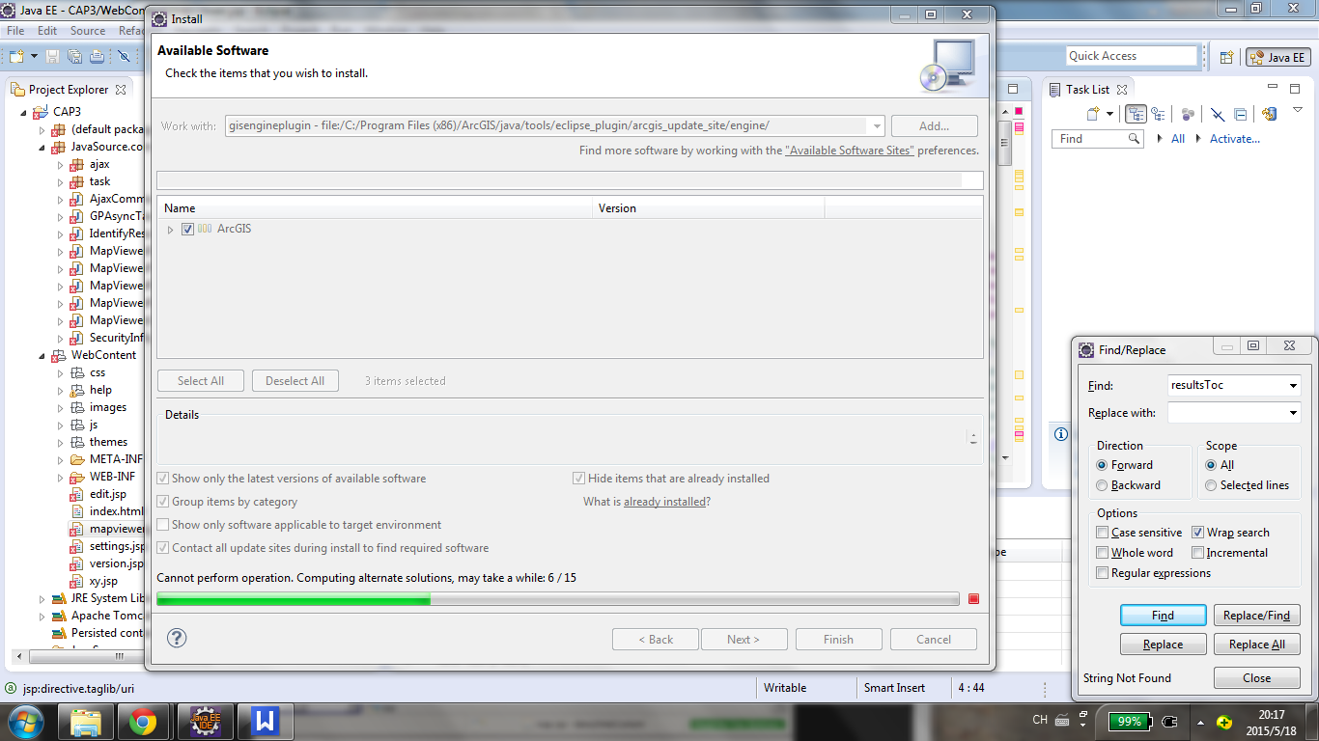

https://www.youtube.com/watch?v=Wcj0QtC-xks
http://resources.esri.com/help/9.3/arcgisserver/adf/java/help/doc/5257ae83-0b1e-4dbb-a120-8a4c79d14d50.htm

